Daniel Kantor

Joshua Freeman

**Homework 4 Report**

For each of the algorithms implemented, the number of steps for the exit to be discovered for BFS was consistently around 92 steps, for DFS it was was typically around 72 steps, for GBS it was always 18 steps from start to exit and A* was the most variable with some 100 runs averaging around 200 while some were closer to 300. For the success rate, BFS, DFS, and A* were the most successful, typically completing between 97-100 of the total runs while GBS was slightly less successful, usually successfully discovering the exit around 87 - 93 times. An example output is shown below:

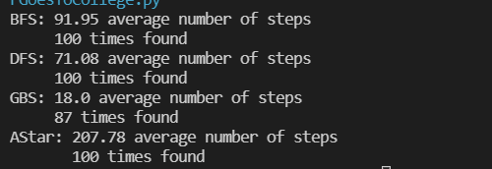

GBS appears to find the path in the shortest amount of steps as it is rather straightforward, moving quickly through the grid by comparing heuristics. However, depending on the placement of the walls, the algorithm is more susceptible to failure as it can get stuck looping between two points, as we can see with the higher failure rate. BFS, DFS, and A* all guarantee a solution if a solution is feasible given the position of the walls. However, A* guarantees the optimal pathing which is why it takes so many more steps compared to the two other algorithms as it is necessary for paths to be expanded that will not end up as the optimal solution. The average number of steps for BFS is basically constant at 92 since in order for the exit to be found, which is the bottom rightmost node in the environment graph, all other nodes must be visited to get to that spot. Since we have 100 nodes, minus the 7 for walls, and minus 1 for starting at 0,0, BFS will always take 92 steps to find the exit unless there is a situation with walls where one of the spots is inaccessible, which is why the average is slightly below 92. DFS is slightly more efficient in the number of steps than BFS because not all nodes will be visited before the exit is found.